Springboard School of Data, Data Science Career Track, Capstone 1

Aysen Gungel Colak, 05/19/2021

**Summary**

**Data set and features**

The aim of the project was helping the Big Mountain Ski Resort in Montana to maintain or increase its profit margin by offsetting the newly added chair cost of $1.54M with a data-driven price strategy followed by an adjustment to the ticket prices.

The former pricing strategy before data science’s involvement was charging a premium above the average price of resorts in its ski resort market segment. This approach resulted in a suspicion that Big Mountain does not get advantage on its facilities as much as it could.

Positioning in the market average does not provide the business which facilities would add more value. A data-driven, analytical approach highlights a number of changes in facilities that will provide value by either cutting costs without reducing the ticket price or supporting an even higher ticket price.

This analysis uses 2 data-sets: One dataset involves state population data while the other involves U.S ski resorts and facilities data. The analysis is not based on Big Mountain Ski Resort’s facilities data itself, rather on other available ski resort’s data.

The features that emerged as significant to weekend adult ticket price are:

* vertical_drop
* Snow Making_ac
* total_chairs
* fastQuads
* Runs
* LongestRun_mi
* trams
* SkiableTerrain_ac

Looking at where Big Mountain Resort ranks among overall among other resorts in the segment:

**Ticket Price(in dollars):**

**Segment**

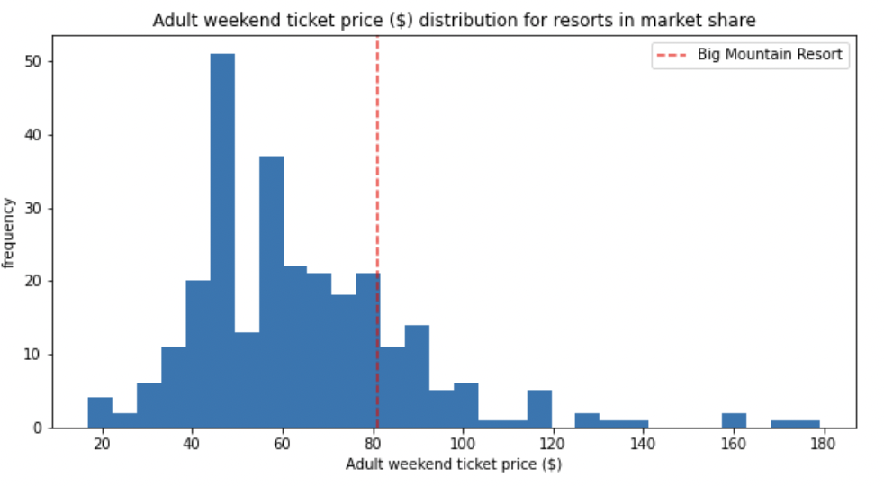

**Montana Only**

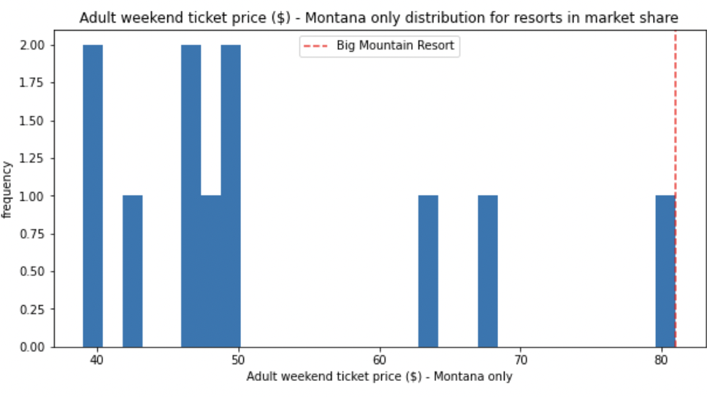

**Vertical Drop(in feet):**

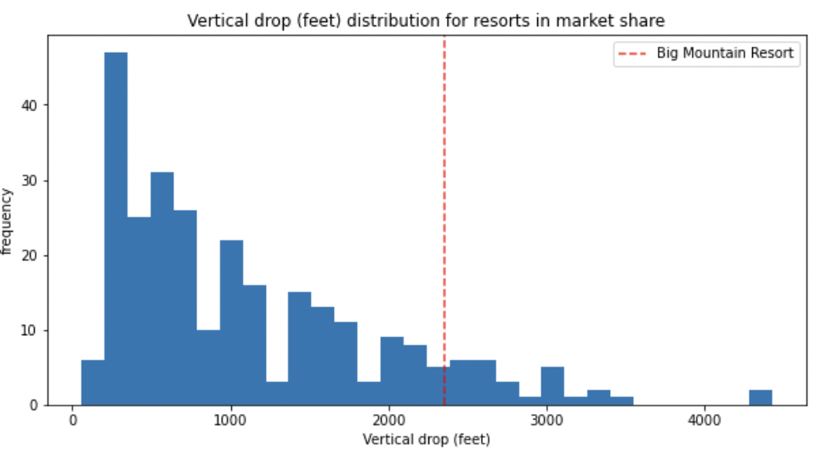

Big Mountain is doing well for vertical drop, but there are still quite a few resorts with a greater drop.

**Snow Making Area(in acre):**

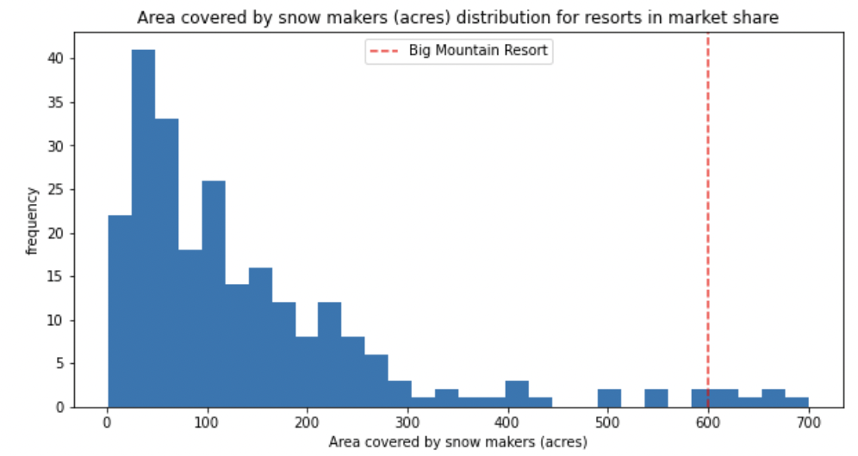

Big Mountain is running on the top for a snow making area.

**Total Number of Chairs:**

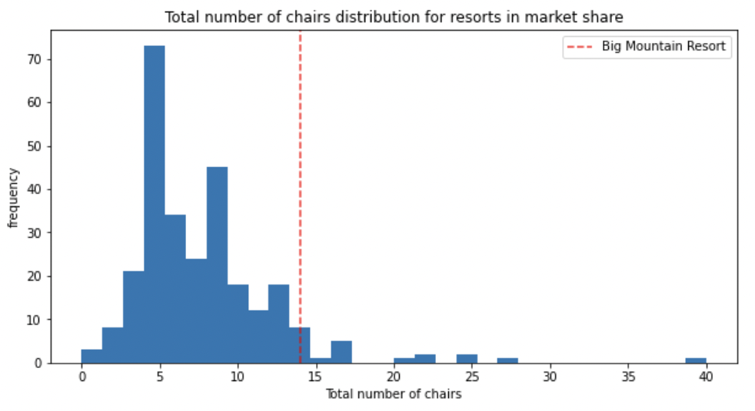

Big Mountain has amongst the highest number of total chairs, resorts with more appear to be outliers.

**Fast Quads:**

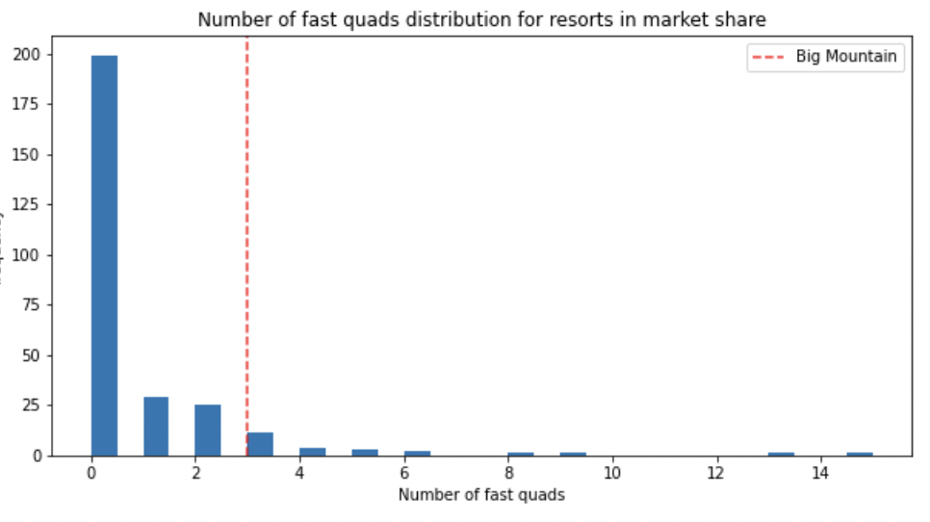

Having fast quads is uncommon among the resorts in market share. The presence of 3 fast quads puts the Big Mountain in

**Runs:**

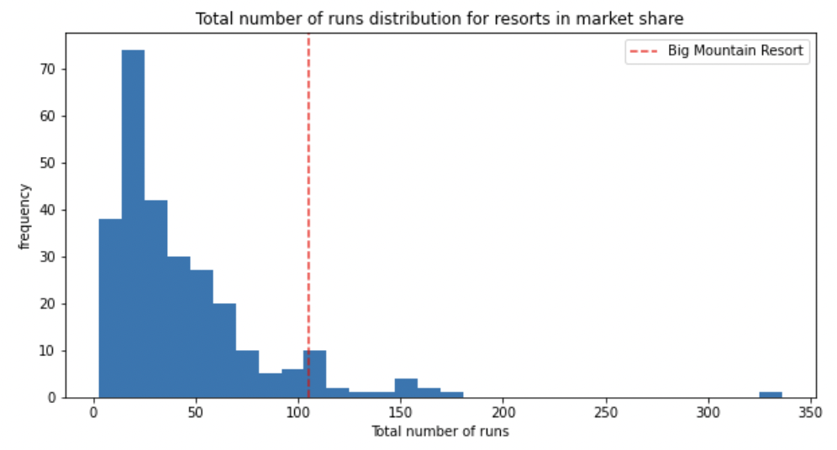

Big Mountain has one of the longest runs. Although it is just over half the length of the longest, the longer ones are rare.

**Longest Run:**

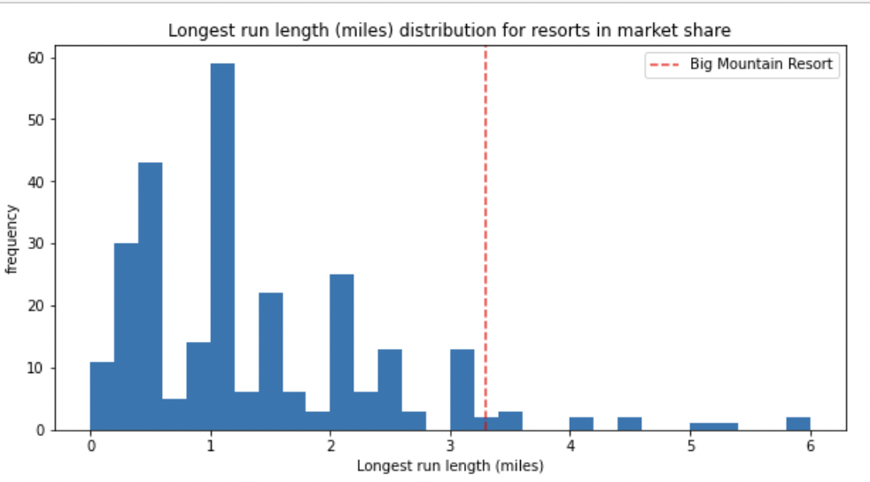

**Trams:**

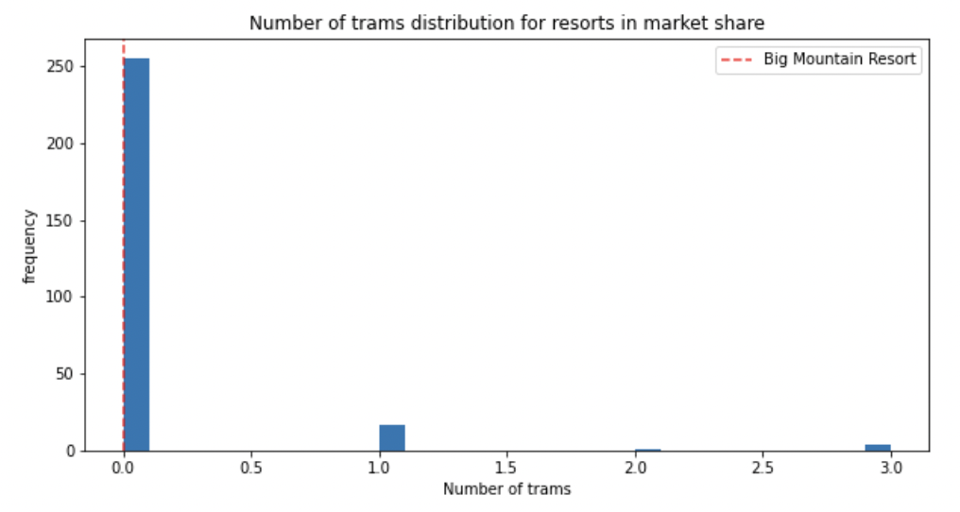

Like other resorts, Big Mountain has no trams.

**Skiable Terrain Area(in acre):**

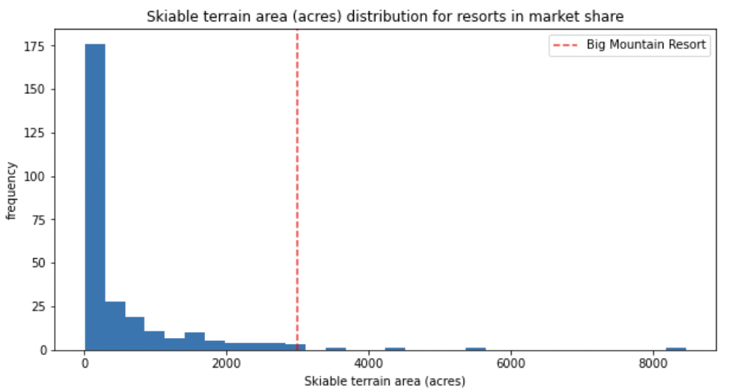

Big Mountain is amongst the resorts with the largest amount of skiable terrain.

**Models**

The linear regression model is based on the following scenarios/options that the hotel shortlisted:

* **Scenario 1:** Permanently closing down up to 10 of the least used runs. This doesn't impact any other resort statistics.
* **Scenario 2:** Increase the vertical drop by adding a run to a point 150 feet lower down but requiring the installation of an additional chair lift to bring skiers back up, without additional snow making coverage.
* **Scenario 3:** Same as number 2, but adding 2 acres of snow making cover.
* **Scenario 4:** Increase the longest run by 0.2 mile to boast 3.5 miles length, requiring an additional snow making coverage of 4 acres.

In addition, the number of skiers is 350,000 and skiers stay 5 days on average.

**The first scenario:**

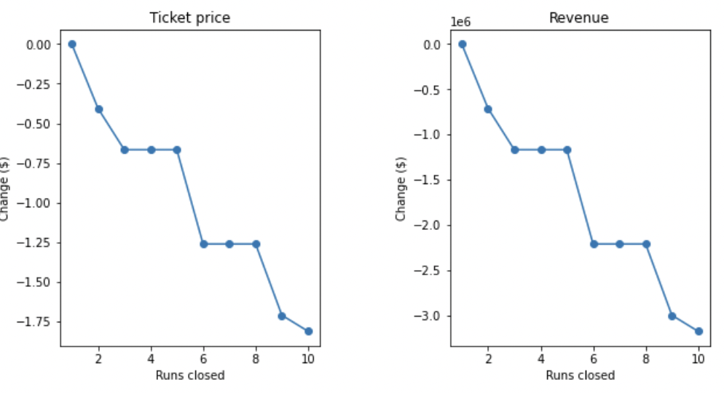

The model says closing one run makes no difference. Closing 2 and 3 successively reduces support for ticket price and so revenue. If Big Mountain closes down 3 runs, it seems they may as well close down 4 or 5 as there's no further loss in ticket price. Increasing the closures down to 6 or more leads to a large drop.

**The second scenario**:

This scenario increases support for ticket price by $8.61

Over the season, this could be expected to amount to $15065471

**The third scenario:**

This scenario increases support for ticket price by $9.90

Over the season, this could be expected to amount to $17322717

**The last scenario:**

No difference whatsoever. Although the longest run feature was used in the linear model, the random forest model (the one we chose because of its better performance) only has longest run way down in the feature importance list.

**Recommendation**

The second and the third scenarios would make a significant difference in terms of value added.

However, decision makers should keep in mind that either solution would bring additional costs like:

Investment cost & maintenance

Electricity

Labor cost

Insurance

Avoidance of risk of avalanches

Time of delay in openings in case of wind, fog, avalanche or accident

Lift capacity = Lift capacity * vertical meters rise

Grooming machines(fuel, leasing, insurance, maintenance, staff, degree of automation)

Grooming cost per hectare

Depreciation.